OM386 Advanced Data Analytics in Marketing
Assignment 1
Due: February 5st, 11:59pm

Random Effects and Hierarchical Linear Models

In this exercise, we will use hierarchical linear models and regressions with random effects for an analytics problem from a credit card company. The credit card company would like to figure out whether offering more promotions to their existing customers can increase the share-of-wallet of the credit card (that is, the share of a consumer's monthly spending using the credit card in her total spending). The company would also like to figure out what customer characteristics make them more responsive to promotions.

The company conducted a field experiment by randomly selecting 300 customers and offering them different monthly promotions for 12 months. The share-of-wallet data were recorded in each month for every customer. The data set also included some consumer characteristics. Please download the data "CreditCard_SOW_Data.csv" from Canvas. It has the following variables:

ConsumerID | ID's of the sampled consumers
History | How long (number of months) the customer has been using the card before the experiment
Income | The customer's annual income
WalletShare | The card's share of wallet in the consumer's total monthly spending
Promotion | Index of monthly promotion activity –higher index indicates more pomotions
Balance | The customer's unpaid balance at the beginning of the month

1). Please read the data into R and create a data frame named "sow.data". Please convert consumer ID's to factors and create the following 2 variables in the data frame: logIncome = log(Income) and logSowRatio = log(WalletShare/(1-WalletShare)).

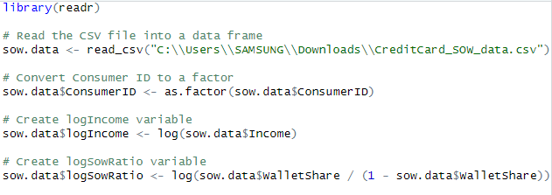

2). Use the function lm( ) to run the regression

logSowRatio_{ij} = β₀ + β₁×History_{i} + β₂×Balance_{ij} + β₃×Promotion_{ij} +
β₄×History_{i}×Promotion_{ij} + β₅×logIncome_{i}×Promotion_{ij} + ε_{ij}

Copy and paste the results here.

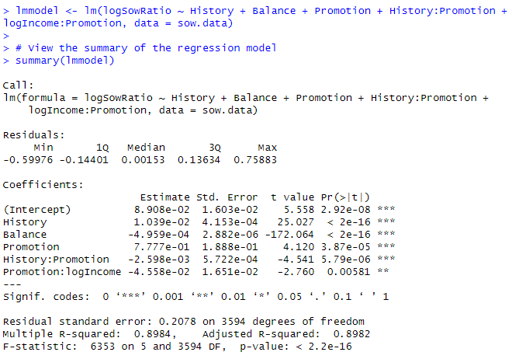

3). Estimate the following hierarchical linear model using the function lmer( ) in the R package "lme4"

logSowRatio_{ij} = β_{0i} + β₁×Balance_{ij} + β_{2i}×Promotion_{ij} + ε_{ij}

β_{0i} = μ₀ +μ₁×History_{i} +ζ_{i}

β_{2i} = γ₀ +γ₁×History_{i} +γ₂×logIncome_{i} +ξ_{i}

Following what we did in our class, please rewrite this hierarchical linear model as a linear mixed effect regression.
Which variables (and interactions) in the regression have fixed effects? Which ones have random effects? Specify the variables in lmer() and run the regression. Copy and paste the summary() of the model results here.
Please interpret the estimated fixed effects in the regression.
Rewrite the model as
logSowRatio_{ij} = ζ_{i + (}γ₀ + γ₁×History_{i} + γ₂×logIncome_{i} +ξ_{i} ) × Promotion_{ij} +ε_{ij}
= μ₀ +μ₁×History_{i} + β₁×Balance_{ij} + γ₀ ×Promotion_{ij} + γ₁×History_{i} ×Promotion_{ij} + γ₂×logIncome_{i}×Promotion_{ij} +ζ_{i} + ξ_{i}×Promotion_{ij} + ε_{ij}

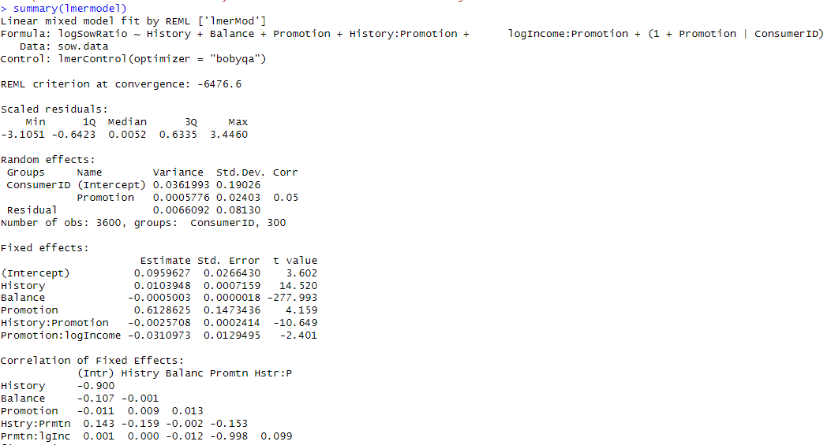
- the fixed effects are shown as above, which are the overall intercepts and slopes that do not vary across individuals or groups in the data:
- μ 0 ​ (Intercept) The estimated starting point for the log share of wallet ratio is about 0.0959627. When we transform this back to the original scale by taking the exponential, we get approximately 1.1. This implies that, when all other variables are at their reference points, the share of wallet is around 10% higher.
- μ 1 ​ (Effect of History on the Intercept) With each additional unit increase in History, there is an expected increase of roughly 1.04% in the share of wallet ratio. This reflects the relative change in the share of wallet ratio attributed to each extra month of card history.
- β 1 ​ (Effect of Balance) An increase in the Balance is associated with a slight decrease in the share of wallet ratio. The exact amount of decrease is not specified here.
- γ 0 ​ (Intercept for the effect of Promotion) A one-unit increase in Promotion is linked to a significant rise in the share of wallet ratio, estimated at 84.57%.
- γ 1 ​ (Effect of History on the slope for Promotion) The interaction term suggests that for each unit increase in History, the influence of Promotion on the share of wallet ratio decreases by approximately 0.0025708.
- γ 2 ​ (Effect of logIncome on the slope for Promotion) For each 1% increase in Income, which we interpret through the logIncome variable, there is an expected decrease of about 0.000310973
Compare model fit using AIC() with the model in (2).
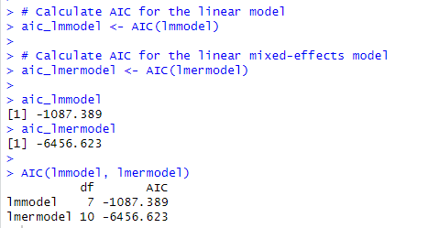

- The AIC for the linear model (lmmodel) is -1087.389 with 7 degrees of freedom. The AIC for the linear mixed-effects model (lmermodel) is -6456.623 with 10 degrees of freedom. A lower AIC value indicates that lmermodel is a better fitting model, taking into account the number of parameters used. since the lmermodel has a much lower AIC value compared to the lmmodel, which despite its greater complexity with more parameters, it provides a substantially better fit to the data. Moreover, the difference is much larger than 10, suggesting that the lmermodel is more appropriate for your data than the lmmodel. Therefore, we can conclude that the lmermodel accounting for the non-independence of the observations through its random effects, which is particularly important in hierarchical data situations.
Linear and Hierarchical Linear Models: Bayesian Estimation

In this exercise, we will practice Bayesian estimation for hierarchical linear models and regressions with random effects using the same dataset "CreditCard_SOW_Data.csv".

1). Use the function MCMCregress() in the R package "MCMCpack" to estimate the linear regression

logSowRatio_{ij} = β₀ + β₁×History_{i} +β₂×logIncome_{i} +β₃×Balance_{ij} + β₄×Promotion_{ij} + ε_{ij}

Use the summary() function to find the results of the estimation. Copy and pastes the results here.
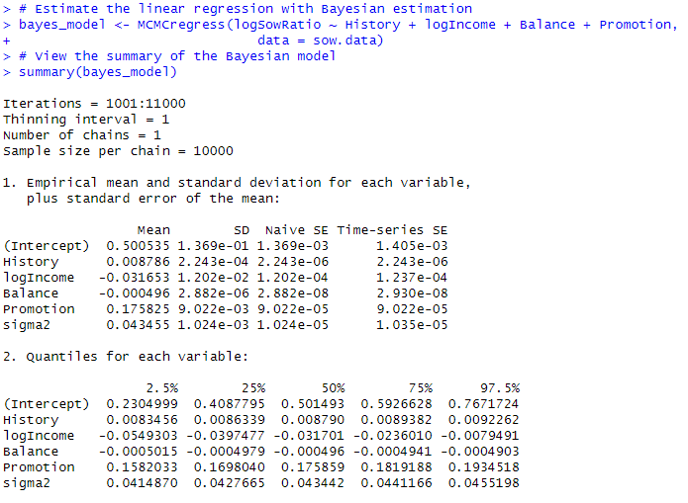
From the Bayesian posterior intervals (use 2.5% and 97.5% quantiles of the simulated posterior distributions), are regression coefficients significant at the 5% level?
- Intercept: The 2.5% quantile is approximately 0.230 and the 97.5% quantile is 0.767. Since zero is not within this interval, we can say that there is strong evidence that the intercept is different from zero.
- History: The 2.5% quantile is approximately 0.008 and the 97.5% quantile is 0.009. Zero is not within this interval, suggesting strong evidence that the History coefficient is different from zero.
- logIncome: The 2.5% quantile is approximately -0.054 and the 97.5% quantile is -0.008. Zero is not within this interval, indicating that there is strong evidence that the logIncome coefficient is different from zero and the effect is negative.
- Balance: The 2.5% quantile is approximately -0.0005 and the 97.5% quantile is -0.0004. Zero is not within this interval, but given the scale and close proximity to zero, the practical significance may be questionable.
- Promotion: The 2.5% quantile is approximately 0.158 and the 97.5% quantile is 0.193. Zero is not within this interval, suggesting strong evidence that the Promotion coefficient is different from zero.
- sigma2: The 2.5% quantile is approximately 0.041 and the 97.5% quantile is 0.045. This is the variance of the residuals, and it is always positive. Its credible interval does not include zero, as expected, because variance cannot be negative.

Use the plot() function to plot the posterior sampling chains and the posterior densities for β₂ and β₃; copy and paste the results here.

2). For the hierarchical linear model below,

logSowRatio_{ij} = β_{0i} + β₁×Balance_{ij} + β_{2i}×Promotion_{ij} + ε_{ij}

β_{0i} = μ₀ +μ₁×History_{i} +ζ_{i}

β_{2i} = γ₀ +γ₁×History_{i} +γ₂×logIncome_{i} +ξ_{i}

use the function MCMChregress( ) in the R package "MCMCpack" for its Bayesian estimation.

Please copy and paste the Bayesian estimation results of the fixed effects (same fixed effects as in (3)) in the model using summary("yourBayesianModelName"$mcmc[,1:6]).

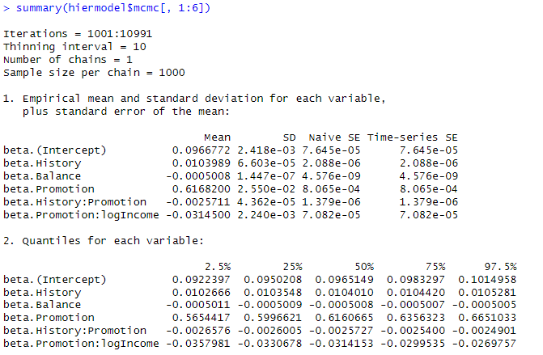
From the Bayesian posterior intervals, are the fixed effects significant at the 5% level?
- Intercept
  - The 95% credible interval ranges from approximately 0.092 to 0.101, which does not include zero, indicating strong evidence that the intercept is credibly different from zero.
- History
  - The 95% credible interval ranges from approximately 0.010 to 0.011, which does not include zero, indicating strong evidence that the effect of history is credibly different from zero.
- Balance
  - The 95% credible interval ranges from approximately -0.0005 to -0.0005, which does not include zero. Although the interval is entirely below zero, the magnitude is very small, so the practical significance might be limited.
- Promotion
  - The 95% credible interval ranges from approximately 0.566 to 0.656, which does not include zero, indicating strong evidence that the effect of promotion is credibly different from zero.
- History:Promotion interaction
  - The 95% credible interval ranges from approximately -0.0027 to -0.0024, which does not include zero. This indicates strong evidence that the interaction between history and promotion is credibly different from zero, with a negative effect.
- Promotion:logIncome interaction
  - The 95% credible interval ranges from approximately -0.036 to -0.029, which does not include zero. This indicates strong evidence that the interaction between promotion and log income is credibly different from zero, with a negative effect.
In summary, all the fixed effects have credible intervals that do not include zero, suggesting strong evidence that they are credibly different from zero at the 5% level.

Use the plot() function to plot the posterior sampling chains and posterior densities for μ₁, γ₁ and γ₂; copy and paste the results here.
